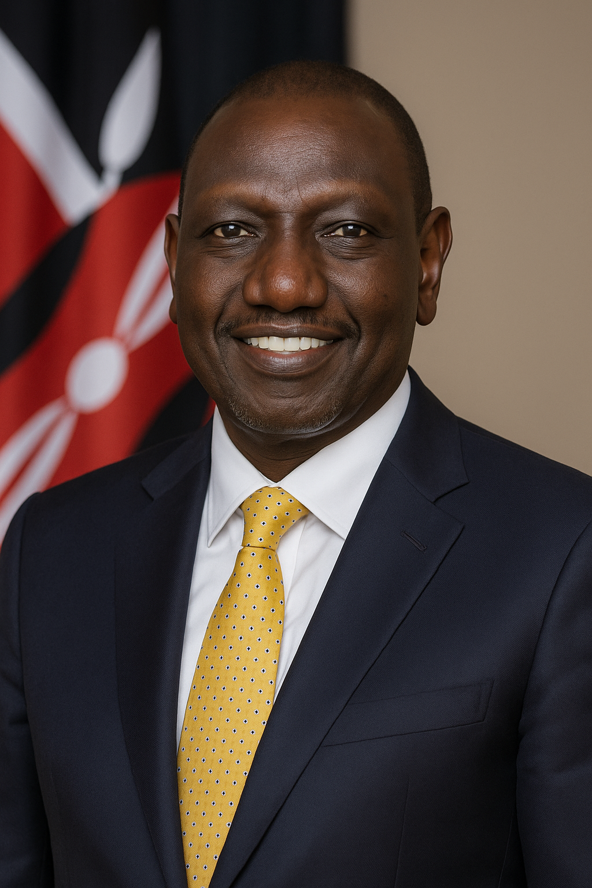
His Excellency Dr.William Samoei Ruto. C.G.H.
President of the Republic of Kenya
and Commander-in-Chief of the Defence Forces

